**USE CASE:**

**State Diagram:**

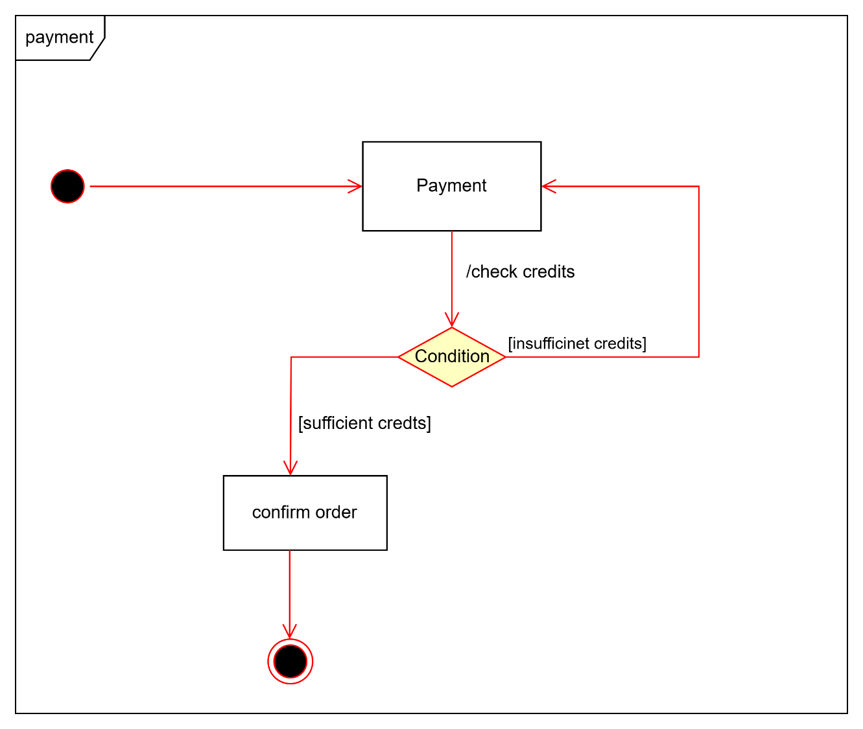

**Sequence Diagram:**

**Component Diagram:**

**Class Diagram:**

